2024 To Do’s

2/25/24 - Team-Wide Meeting #2
- Everyone to run code with their assigned countries + flag anything that does not work
PROBLEMS WITH CODE:
Belgium - Ronil
SDV Sensitivity and Contingency Strategy:
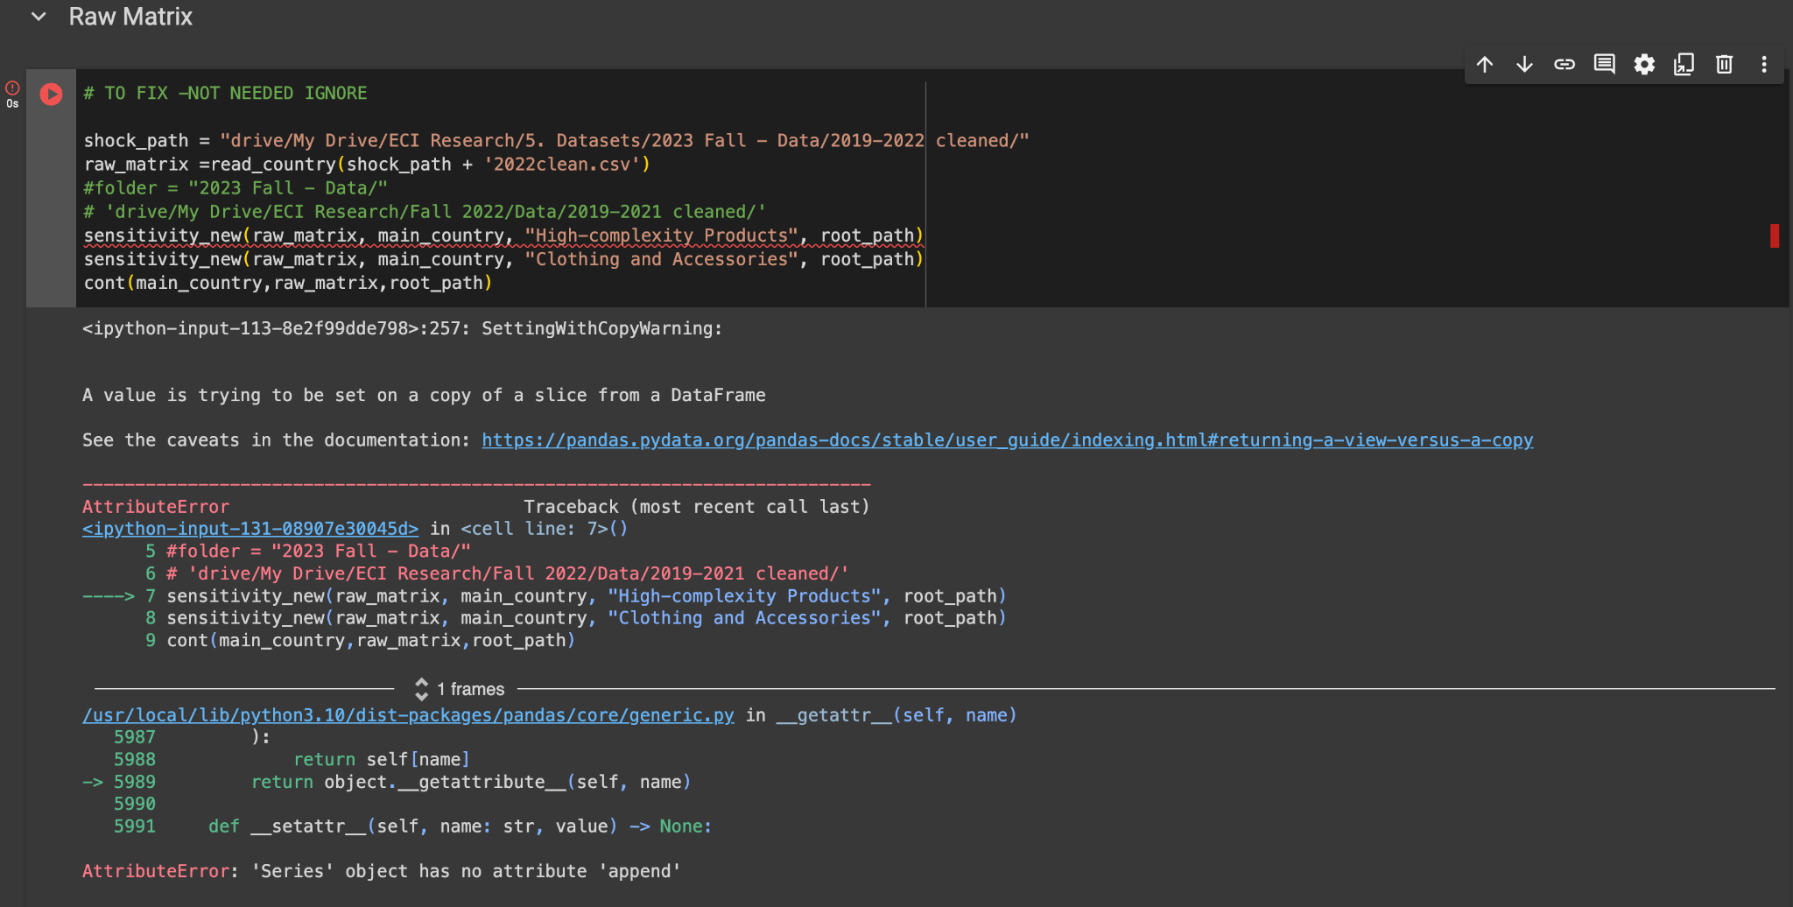

Sri Lanka - Jane
Greedy 5%
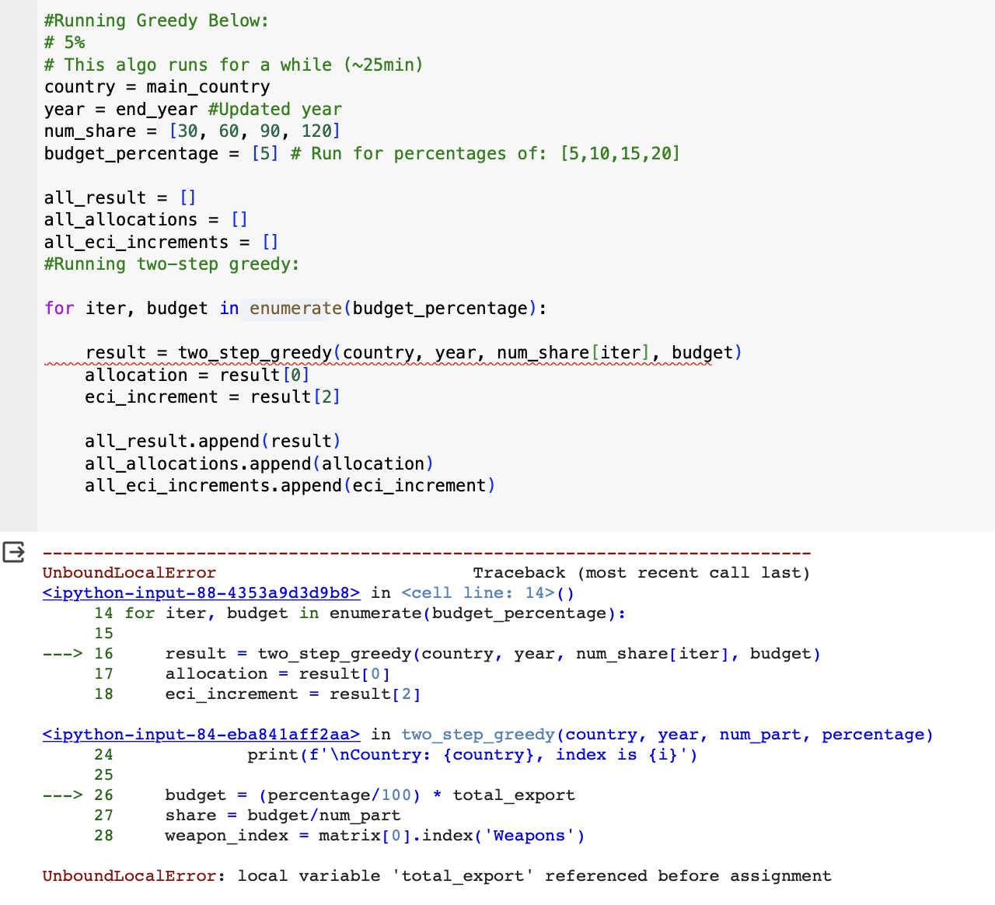
ECI GDP Graph
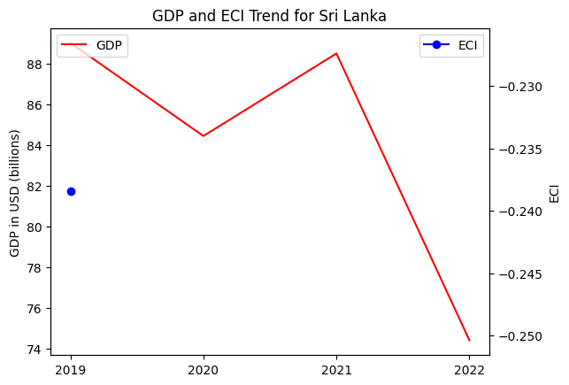

Thailand

- Report Overview in old report mentions Brazil rather than Thailand

Switzerland

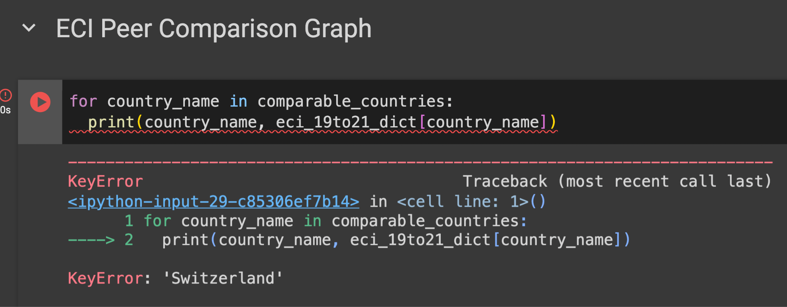
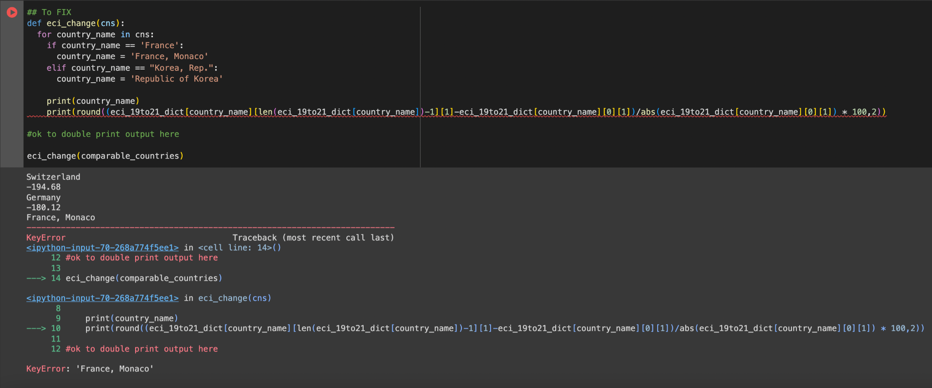

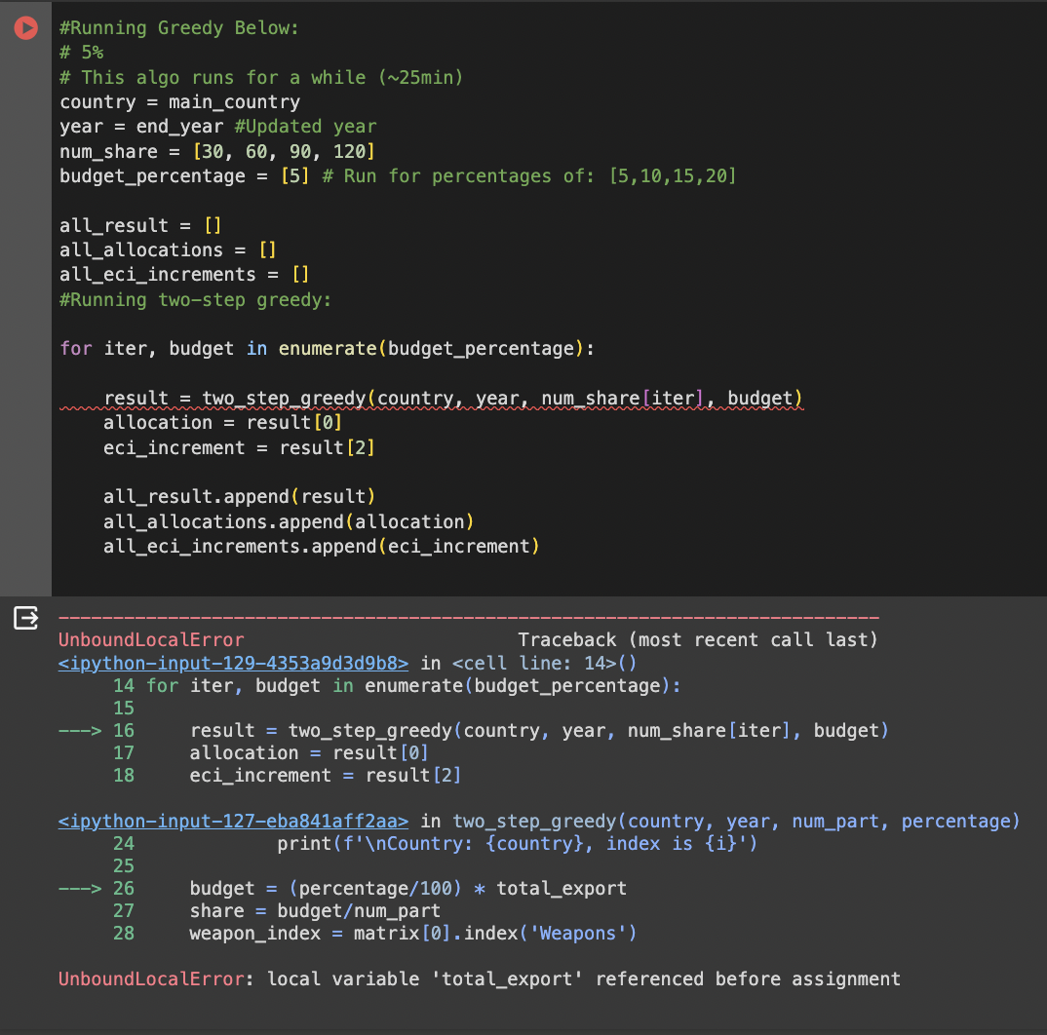
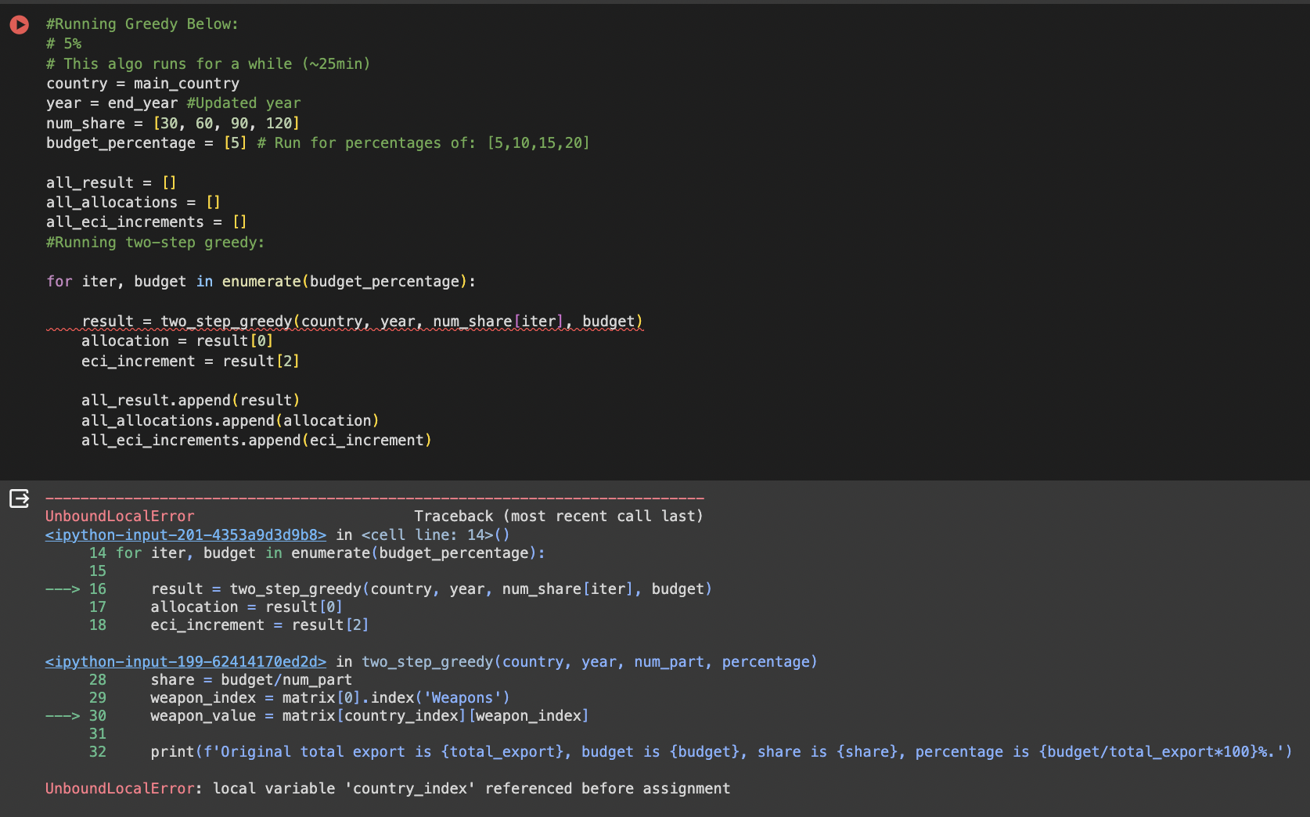
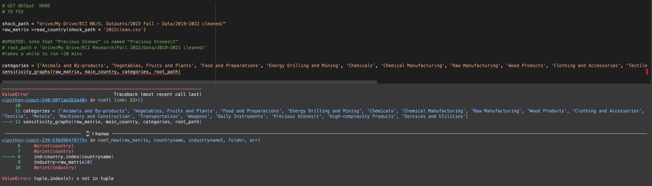
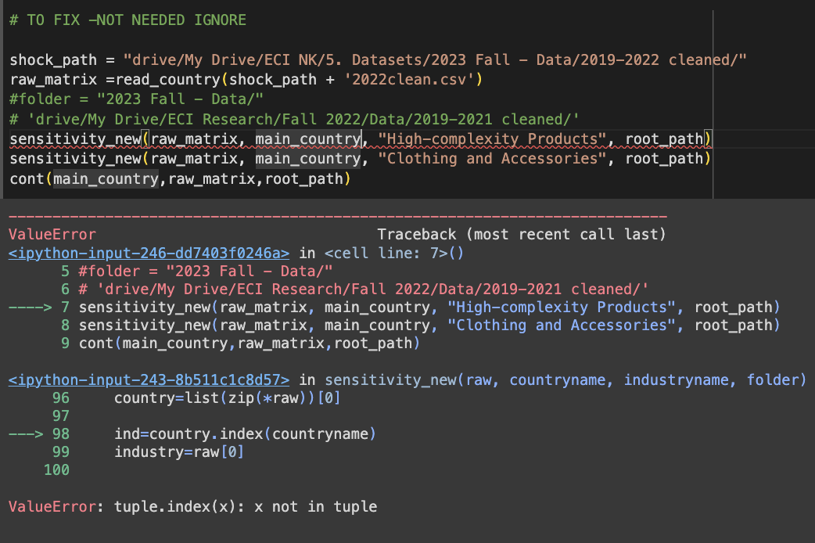
Christina – Panama
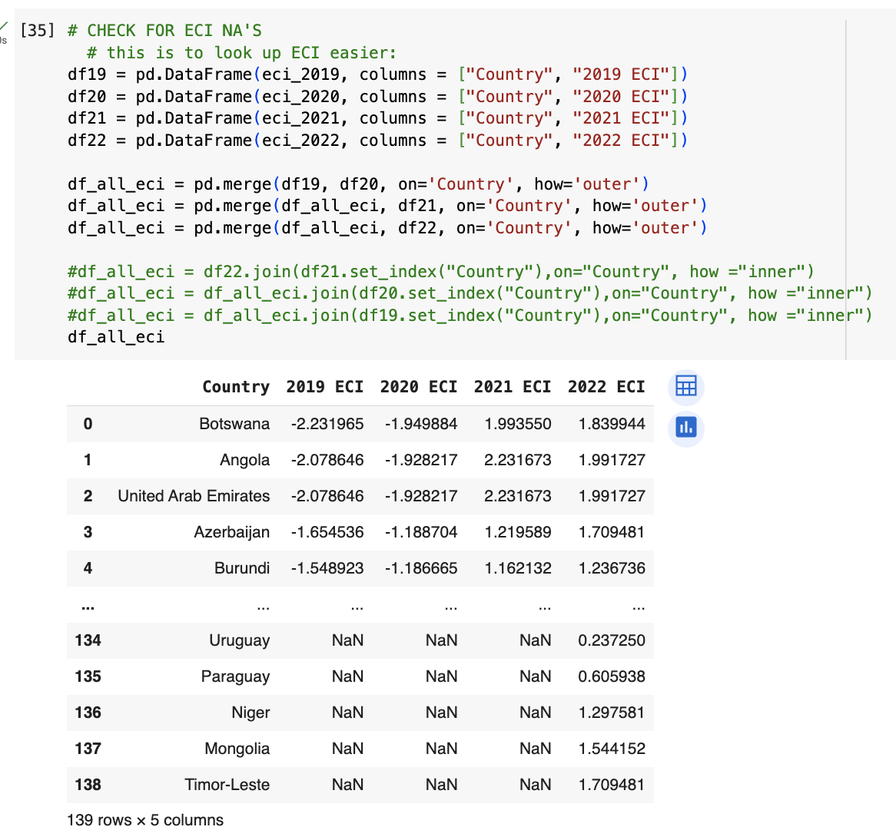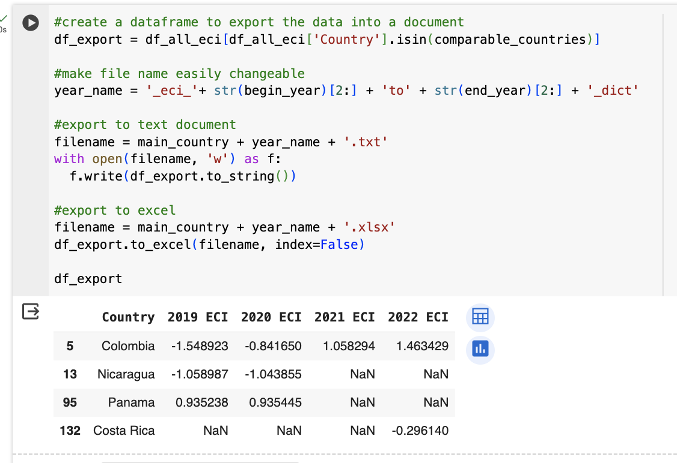
Comparable countries includes ‘Dominican Republic’, idk why it isn’t here, ECI data
Australia
All code works probably

2/9/24 - Team-Wide Meeting #1
- Roster Spring 2024 ​​

Spring 2023/Fall 2023 countries
Namo | Benin, Brazil, Kenya, Burkina Faso, Mauritania
Young | Denmark, Egypt, France, Greece, Mexico
Zev | Chile, Estonia, Senegal, Finland, Germany
Ronil | Italy, Norway, Saudi Arabia, Singapore, Colombia
Christina | South Africa, Togo, Niger, Spain, Sweden

Country Reports Not Linked Correctly
- Asia Pacific: Singapore
- Americas: Colombia
- Europe: Greece, France, Spain, Italy, Norway, Sweden, Egypt, Denmark
- MENA: Saudi Arabia

ECI Meeting Notes:
- MD: Add people to group chat
- Set up recurring bi-weekly meetings where everyone can make it
  - AG: Send out when2meet later
- KM: Relink files for broken links
- JZ: Update links for new reports from Fall 2023
- Cross check country tracker and website
  - Document which countries are on the website and which version is uploaded (2013-2018 or 2019-2021)
  - Update the country tracker
  - Reorganize country tracker
- KM: Share Google Drive
- KM: Add edit access to website
- Newbies: Update the slides
- Add summary
  - Observation: Lower complexity - boosted their GDP more than countries that focused on high complexity
  - Idea: A comprehensive report for all countries to compare - key takeaways —> insights about countries and trends
  - Talk about what the country reports include and what we look at
- MD/KM: Poster for senior research fair - senior design expo (look through that)
- Reach out to Jessica
  - Connect new leaders
  - Serafina dinner - April (make sure it doesn’t conflict w seniors)
- No News from Vankee: Email him again and cc new people. Attach the reports to the email - About collaboration with the world bank
- Countries to Add:
  - !!!! Australia
  - !!!! New Zealand
  - Sri Lanka
  - Panama
  - Venezuela
  - Belgium
  - Netherlands
  - Switzerland
  - Algeria
  - Tunisia
- Let newcomers critique and get their suggestions

Code To-Do’s (from 2023)

- UPDATED & CONSOLIDATED CODE from Fall 2023: All Code_v04.ipynb

First, old code files are located here. They are named in the order that you should run them. Do NOT modify the main version until you have tested it on your end and got confirmation from others on the team.

To-Do Items we need to address:

- Main idea: make the code more user-friendly, readable, and efficient

0. General:
- Each code file needs to have a description on top briefly explaining what it does and what it produces
  - ex. “It takes in and cleans GDP and __ files. Then, it outputs graphs for GDP and ECI for a specific country, and GDP and ECI graphs for the main country and the comparable ones, …”

- Identify any irrelevant parts of the code (but do NOT delete them. Leave a comment #TO FIX or flag & group it otherwise )
  - consolidate old/unused code
- Sections: each code needs to be split into clear sections and subsections for easier navigation by topic

1. Datasets:

- Fix any mixed matches in country’s names between the ECI and GDP dicts (easier & better is to do country names’ cleanups in the initial datasets)
- Data Cleanup: if a piece of data for the country is missing, you want to do that fixing at the top of the code
- Add file reading into a loop that is parametrized by years:
  - You might need to re-upload data for 2013-2018 into folders
  - Make sure you are able to read data from 2013-2018 and 2019-2021 together and separately (i.e. as a user, I only want to provide start and end year. You should handle any cleanups that are currently in the code or different ways of reading the data)
  - Make sure you make it is easy to be able to add/incorporate more years of analysis if needed
  - Same applies to paths to folders

2. Make all output automatically exportable / saved on the left menu under “files”:

1. Any relevant (text) output should be saved by printing output into a file and into command lines:
with open('my_file.txt', 'w')

- Because it can be difficult to look for which part of the output is relevant when there are progress updates; clearly outline which part of the output should be put into the report
  - E.g., Greedy code in 1. (below) - refer to exporting all text output into a file
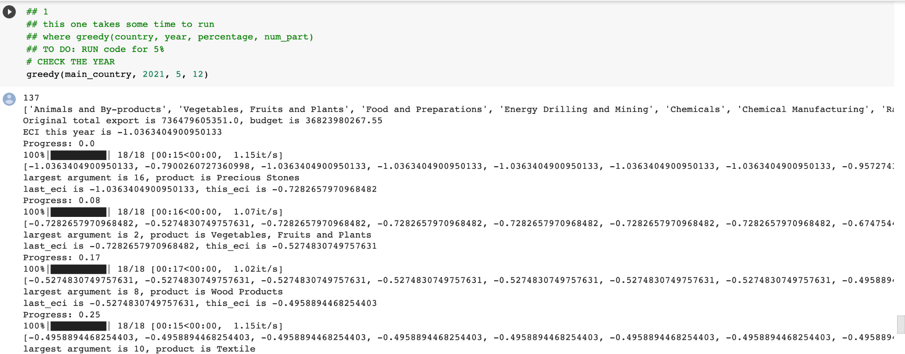

2. Tables export
(as you’ll see in some reports, there is more information on other regions’ countries’ performances) - make sure to parametrize them as well! Give users a choice of which tables to produce for what metrics - see section 3.

#Any tables should be saved using something like:
data.to_csv('YOUR_FILE/HERE.csv')
3. Graphs export
- Any graphs should be saved with files on the left as well (one of the codes has an example)
- Fix graph outputs: in particular, ECI and GDP graphs have a weird x-axis with ticks

3. Parametrizing any variable names:
- See file exporting and path by years above
- Anything that needs manual changes should only be changed at the top of the code with a comment #TO DO and what exactly is needed to be done.
  - Pay attention to paths to the files, anything with “main_country”, any tables that appear in some reports
  - Make variable names clearer/more accurate/intuitive and include a brief description

For instance: 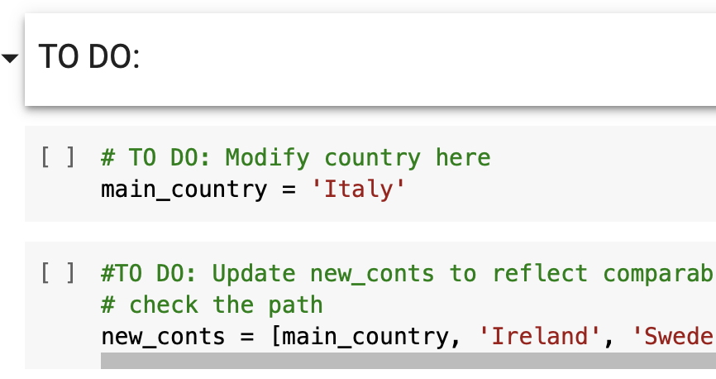

4. Code-specific:
- Fix SOI code so it doesn’t throw an error at the very end
- Fix SDV code so the SDV ECI table works

Country names
Export graphs
Modifying paths,
Adding for loops
Changing variable names

Questions:

Fall 23 edits:
SOI:
- Soi_adi is defaulting to three countries, needs to be the entire list
- Errors for regression
- Cannot get r^2
Greedy:

